Abstract

Pneumonia is the inflammation of lung tissue caused by many factors like viral or bacterial infection. It is estimated that 2.5 million people die each year of pneumonia[1]. Deep Learning based models are regularly used for medical image segmentation. This article presents a brief on various deep learning models developed by researchers that base their models on CNN, RNN and LSTM .

Keywords: Pneumonia, Review, CNN, RNN, LSTM, Medical Image Segmentation

Section 1 : Introduction:

In digital image processing, image segmentation is the process of identifying certain recurring patterns in a set of images. In the specific case of Medical Image Segmentation, medical image data formats like CT-Scan or X-rays are used to identify certain aspects of the image like tumors, organ defects, etc as per the target of the study undertaken. Pneumonia is generally identified in humans based on X-ray data. A lot of research has been done in Medical Image Segmentation to automate the identification of pneumonia patches using various deep learning techniques.

This has motivated us to write an article reviewing these techniques developed by researchers compare them and suggest improvements to the architecture or approach of this problem.

The rest of this paper is organized as follows. Section 2 goes over the research done in the field and the ones that we would be using to compare later in the article. In Section 3, illustrates the comparison of the algorithms developed by authors in Section 2 . In Section 4, we present our analysis on the performance of the models discussed in Section 3. Our suggestions on relative improvement in the models discussed are described extensively in Section 5. Finally, Conclusion and Future work are presented in Section 6.

Section 2 : Literature Review

Several methods have been introduced for medical image segmentation specifically for pneumonia. In the study done by Hesamian et al. [2], the authors provide a description of state of the art deep learning techniques utilized for modern day medical image segmentation and the challenges faced in applying those techniques. Different type of Convolutional Neural Network and there application form the bases and the backbone of this research. They talk about fully convolutional network (FCN) developed by Long et al. [3] where the last fully connected layer is replaced a fully convolutional layer which allows for better performance compared to previous networks. They also talk about 2.5 D data approach for the problem which carries richer spatial data as compared to 1-D data but is still computationally less expensive compared to 3-D information. Lastly, they write about the use of recurrent neural network [RNN] and long short term memory [LSTM] a type of RNN in medical image segmentation. As RNNs are powered by recurrent nodes they have the power to memorize patterns and generalize the context of the image.

The study by Hesamian el al.[2] focused on the medical image segmentation in general. In [4], Goyal et al. conduct a study specifically to detect pneumonia patterns in x-ray images. The type of pneumonia is determined by the patches on the lungs visible in the x-ray. As the study was conducted on backdrop of covid-19 pandemic. It focused on identifying pneumonia caused by covid-19 against any other viral infection. The model developed in this study was a combination of RNN and LSTM called Fusion and normalization features bases F-RNN-LSTM. The features for the model are generated by using adaptive histogram and filtering to generate a region of interest (ROI) for the model. This model was compared with various other machine learning algorithms like K-nearest neighbours (KNN), Support Vector Machine (SVM) and ensemble decision trees. Their comparison is described later in section 3.

Elshenawy et al. [5] compare a combination of LSTM-CNN model developed with the benchmark MobileNetV2 and ResNet152V2. They use a batch normalization layer before LSTM and 4 blocks of CNN for the purpose of feature extraction . The classification on extracted features is done by a dense neural network and sigmoid activation layer the input for this neural network is create by a flatten layer.

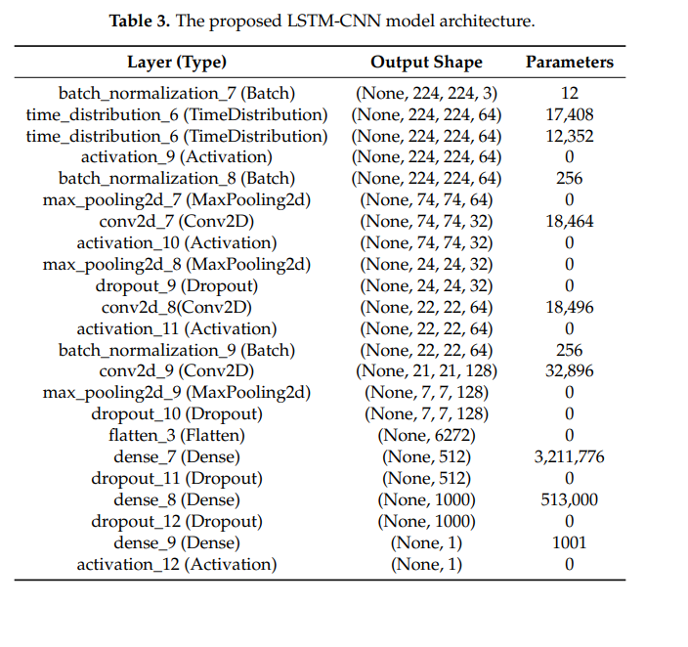Tabel 1. Architecture used in LSTM-CNN model from [5]

Figure 1. Architecture used in LSTM-CNN model from [5]

Section 4. Comparison

This section presents the evaluation and findings from studies conducted by Goyal et al. [4] and Elshenawy et al. [5].

Goyal et al.[4] conducted there research on a data of 2905 images with about 1583 normal chest X-rays, 219 covid-19 and 1345 viral pneumonia chest x-rays. This dataset was trained on the proposed F-RNN_LSTM model in the study with ANN, ensemble tree, KNN and SVM and the results based on evaluation metrics are mentioned below.

Elshenawy et al. [5]. Fetched their publicly available data from Kaggle which consisted of 5856 images with 1583 normal images and 4273 images with viral/ bacterial pneumonia. Here the proposed LSTM-CNN model was compared with existing benchmark ResNet152V2 and MobileNetV2 pretrained model.

6. Analysis

6.1 Challenges in Medical Image Segmentation

Limited Annotated Data

[1] <https://ourworldindata.org/pneumonia>

[2] <https://link.springer.com/article/10.1007/s10278-019-00227-x>

[3] Long J, Shelhamer E, Darrell T: Fully convolutional networks for semantic segmentation. In: Proceedings of the IEEE Conference on Computer Vision and Pattern Recognition, 2015, pp 3431–3440

[4] <https://link.springer.com/article/10.1007/s12652-021-03464-7>

[5] <https://www.mdpi.com/2075-4418/10/9/649>